System Requirements Document

WW Elevators
Sideways Elevator Panel Project

Prepared By
Gary Hutchinson
August 1st, 2026

Executive Summary
WW Elevators needs an elevator control panel capable of facilitating horizontal travel. Their current design supports only horizontal travel. This document proposes an updated design that allows for both travel directions while making use of their original design. The new design will account for three separate elevator tracks on the western side, the middle, and the eastern side of the building.
System Requirements
The new system will
- Perform all functions of the old system, such as floor selection, open and close the door, have a functional emergency button, and be callable to the specified floor.
- Allow for the selection of both the desired floor and the desired building section (west, middle, east).
- Detect the position of other elevator cars and prevent collision.
Performance Requirements
The elevator must choose the fastest path to the specified floor and building section. The emergency button must immediately stop the elevator. The panel system must be able to detect other elevator cars accurately to avoid collision.
Design Constraints
The new elevator panel must:
- Comply with all safety regulations.
- Be relatively compact to ensure compatibility with WW Elevators existing frame design.
- Interface with WW Elevators existing hardware.
Schedule and Budget
The amount allocated for the project is $100,000. The breakdown will be:
- $10,000 for the physical hardware for the prototype.
- $35,000 for the software design team including testing phases.
- $35,000 for the hardware construction team including testing phases.
- $10,000 for the installation team.
- $10,000 will be reserved for unforeseen circumstances including additional man hours as needed.
The project will span 5 weeks.
- Week 1 will consist of software design.
- Week 2 will consist of physical construction of the prototype.
- Week 3 will consist of interfacing the new components with WW Elevators existing components.
- Week 4 will be dedicated to installation.
- Week 5 will be testing and evaluation.

Proposed Design
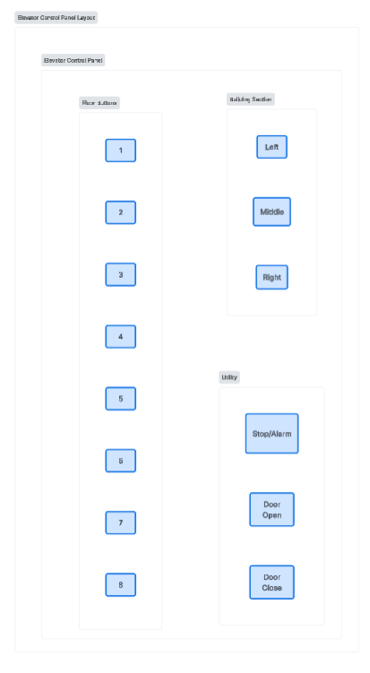

Diagrams
